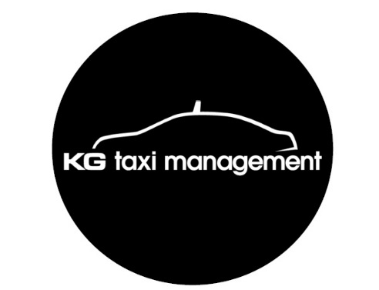

The Queensland Taxi Industry has been in a battle with the intrusion of an international "ride share" organisation known as Uber. All around the world Uber has been disrupting traditional taxi markets without due recognition of existing legislation or laws of the land that may be in place.

Illegal ride-sharing apps represent a significant threat to on-demand passenger transport in Queensland and KG Taxi Management is committed to ensuring illegal enterprises like Uber are not allowed to continue their operation in Queensland.

**In the meantime, provide the very best service possible to your passengers by:**

• Keeping our cabs clean

• Ensuring our drivers are neatly presented in their Black & White Cabs uniform

• Proceeding promptly and directly to each booking upon acceptance

• Offering all customers a friendly greeting

• Assisting our passengers with their luggage and groceries

• Charging the correct fare

• Thanking our passengers for their custom each time they exit our cabs and promoting our own booking app and phone number at an appropriate time during the journey

**Black & White Cabs can:**

• Ensuring we promote our booking app broadly

• Ensuring all our other booking products including our smartphone apps and web bookers are market leading and user friendly

• Ensuring we answer telephone calls for bookings promptly

• Ensuring the booking details are correct the first time

• Thanking our customers for choosing Black & White Cabs

• Making sure our telephone system and integrated booking services are the smartest technology and user friendly

• Continuing to engage in meaningful discussions with Taxi Council and TMR to ensure all providers of door to door on-demand passenger transport services are delivered by organisations that comply with current Queensland legislation

• Promote our safety policies to passengers i.e. Fatigue management, zero blood alcohol level.

Thank you